**Implementation of Network Drive**

## **Network Drive:**

## **How to connect Network Drive (NFS):**

* TS server must be ready Windows 10 Pro Version 21H2(OS Build 19044.1288).
* User should have administrator rights to connect Network Drive (NFS Drive).
* NFS server must be setup before connect Network Drive (NFS Drive).
* NFS client must be installed on TS server.
* Please refer the sheet NFS Server Setup.



* **Steps:** Follow the below steps to connect Network Drive (NFS Drive) on the TS server:
* Login to the TS server.
* Open file explorer.
* Go into This PC. 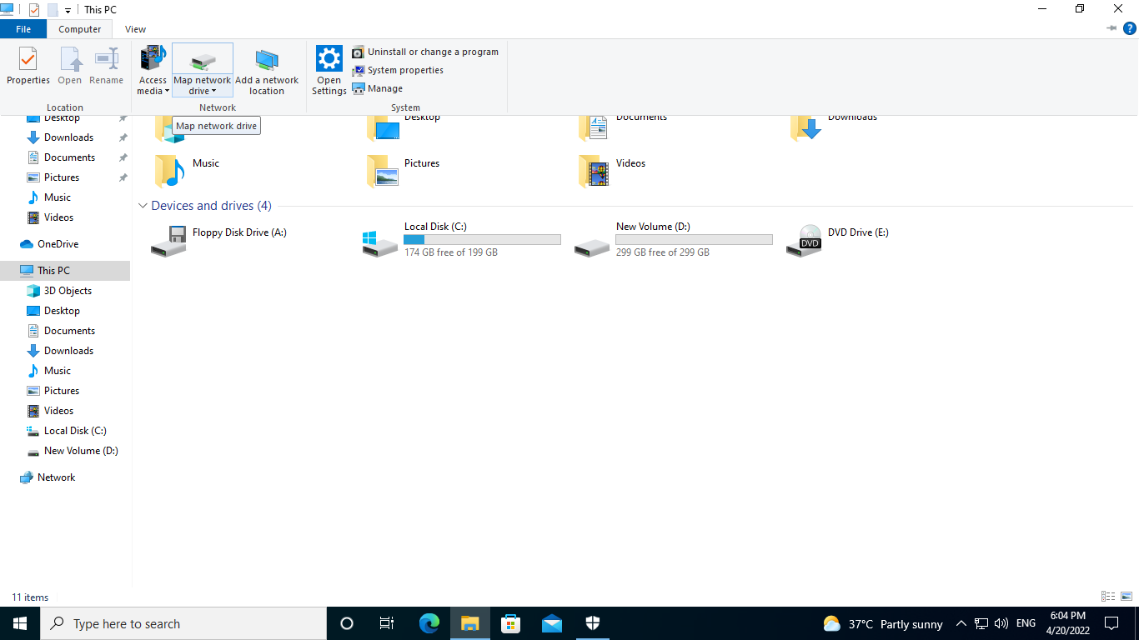
* Click on computer (User can find the "Computer" tab on the top left).
* Click on 'map network drive'.
* Select Drive letter.

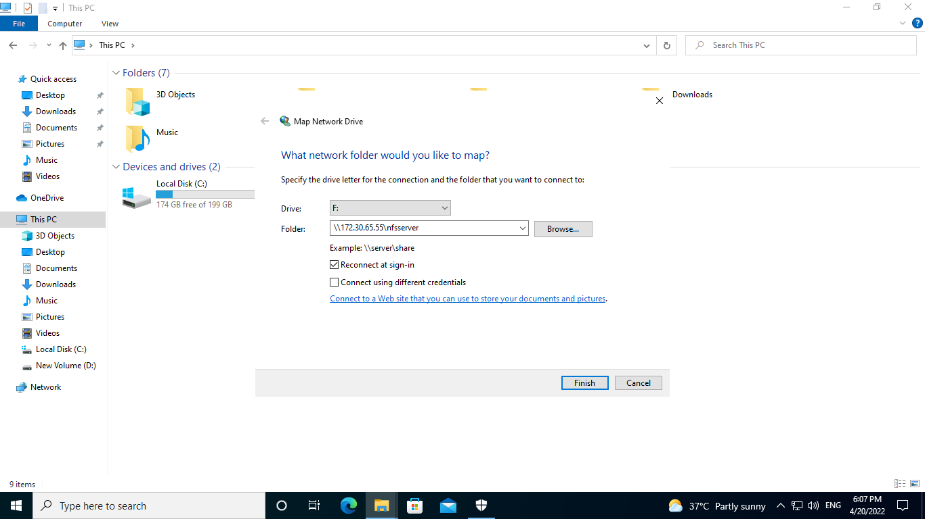

* Enter the NFS server IP address and shared folder into the 'Folder'.
* Example: - \\<NFS_SERVER_IP_ADDRESS>\nfsserver

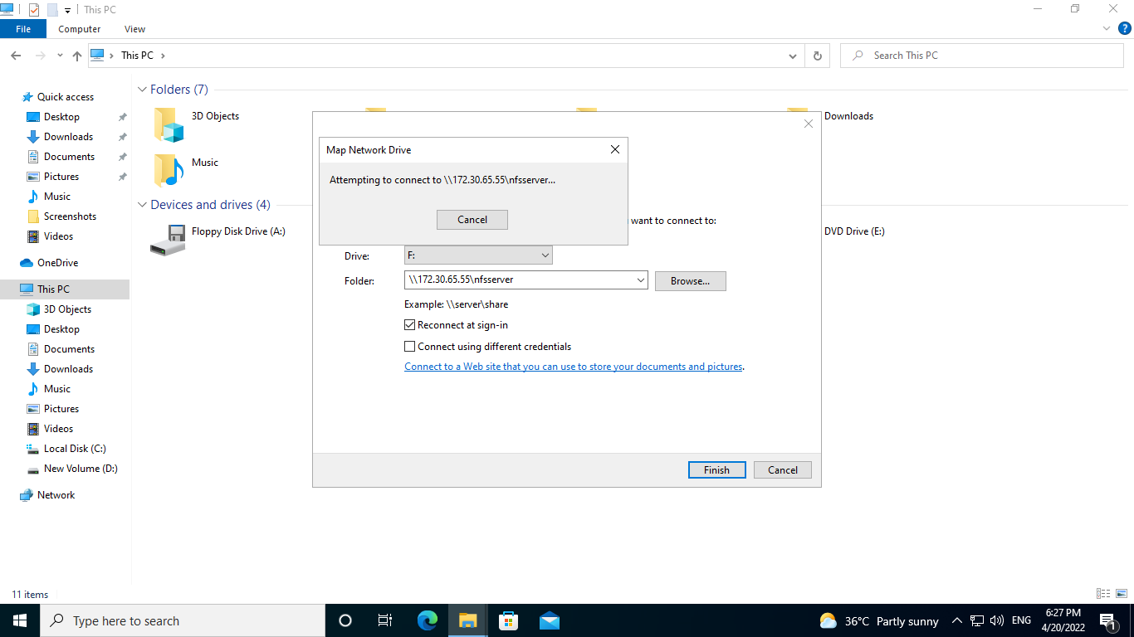

* Click on Finish button.

TS System Network Drive (NFS)

Logs

Fig1: Execution Of command.

## **Evidence:**

* Local Execution with Evidence

Below command executed on MD system

**Command:**  New-PSDrive -Name "<Drive_LETTER>" -PSProvider "FileSystem" -Root "\\<NFS_SERVER_IP_ADDRESS>/<NFS_SERVER_SHARED_DIRECTORY>" -Persist >>(LOG_DIRECTORY)\network_drive.log

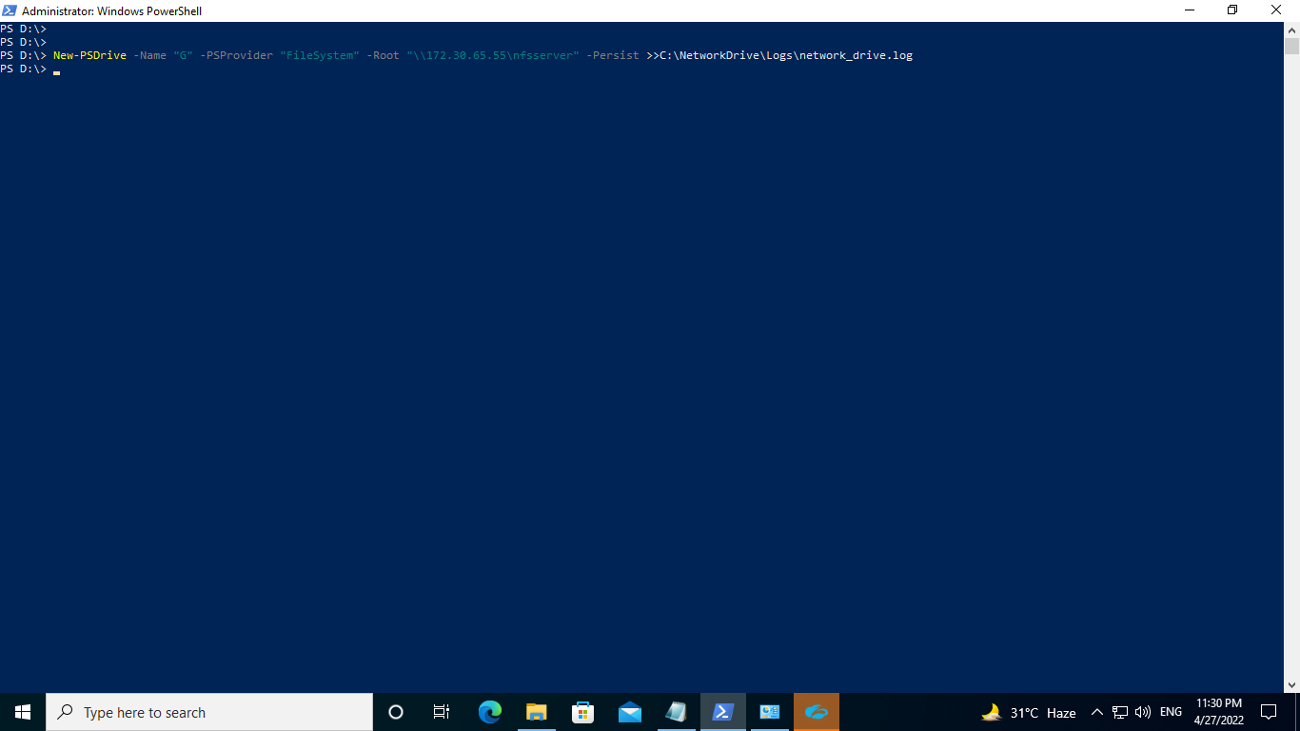

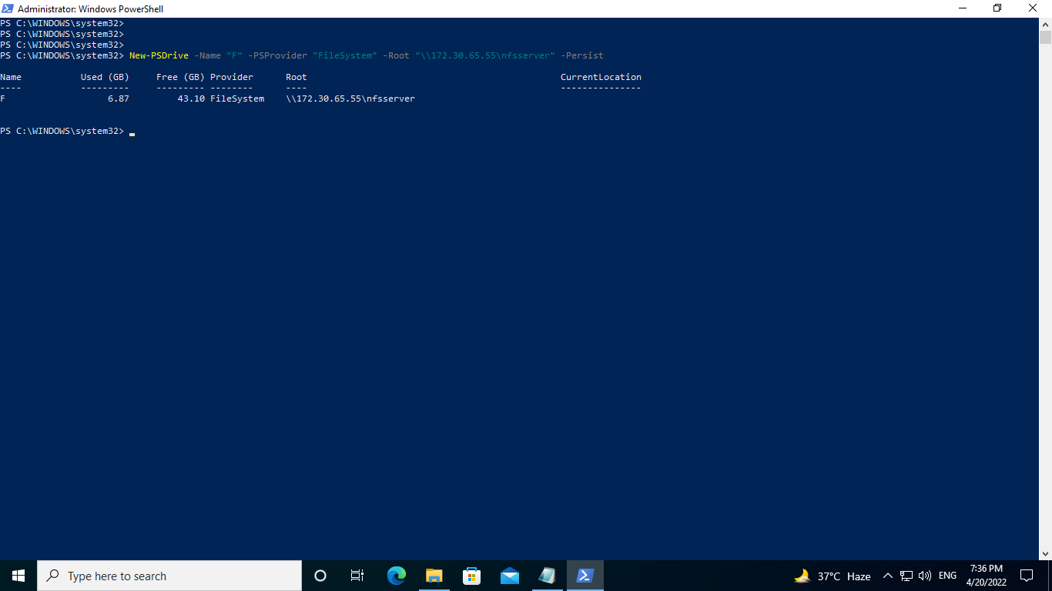

Executed Command on MD System

* Remote Execution with Evidence

Below command executed on MD system

**Command:**

python

import winrm

s = winrm.Session(‘New-PSDrive -Name "<Drive_LETTER>" -PSProvider "FileSystem" -Root "\\<NFS_SERVER_IP_ADDRESS>/<NFS_SERVER_SHARED_DIRECTORY>" -Persist >>(LOG_DIRECTORY)\network_drive.log’)

r.status_code

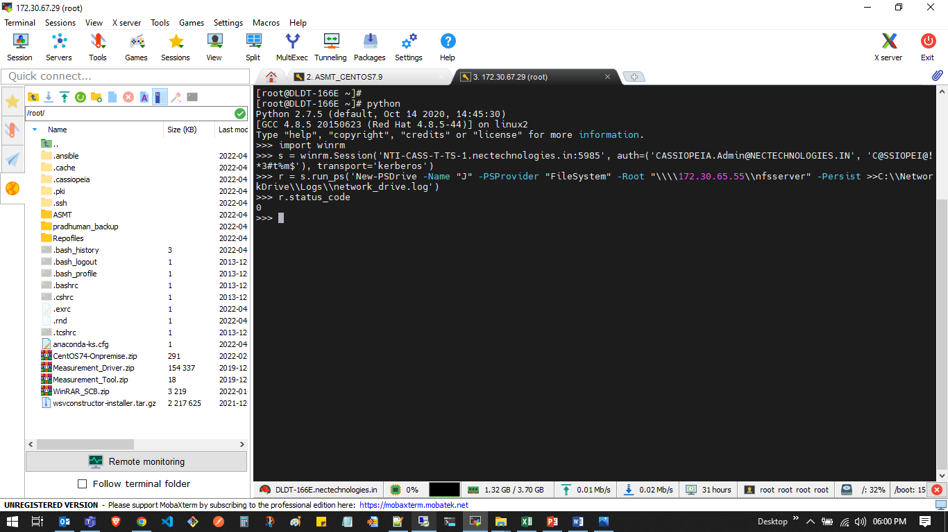

Remote Execution on MD System Successful status evidence

## **Verification:**

Follow below steps to verify that target machine connects with Network Drive (NFS Drive) on TS Server:

1. Login to the TS server.

2. Open file explorer.

3. Go into This PC.

4. User should get the "nfsserver drive" into the "This PC".

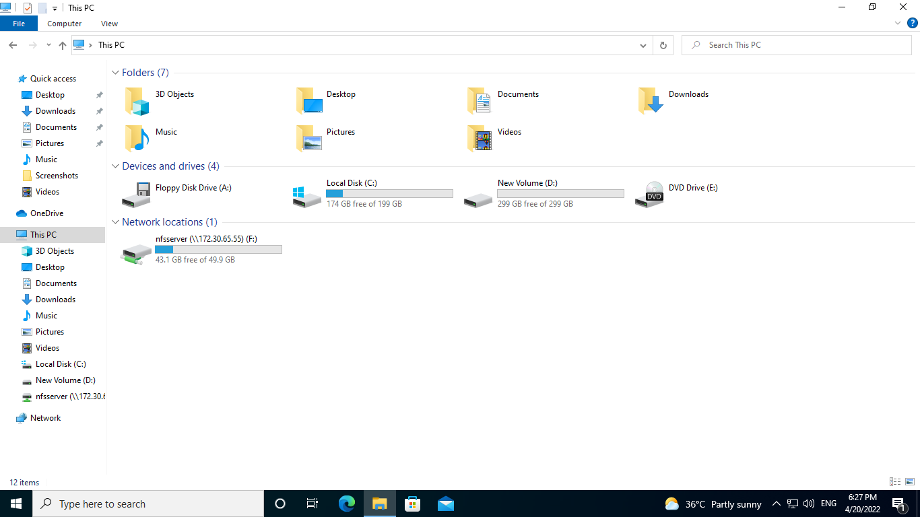

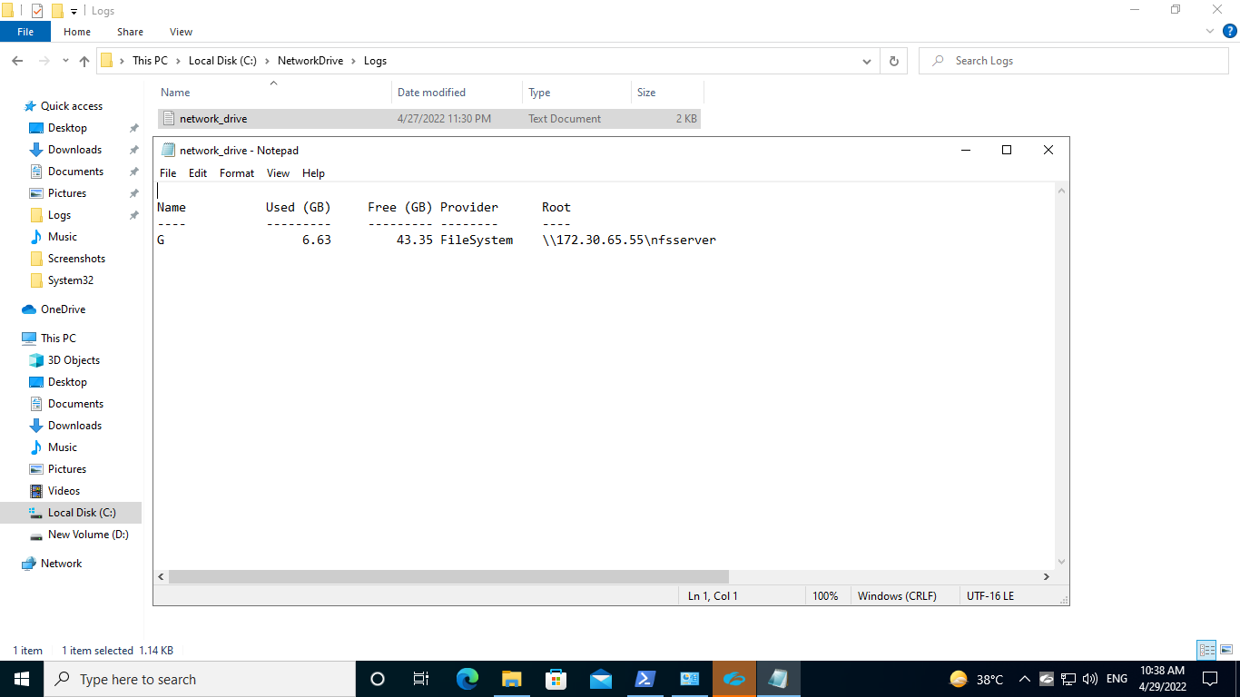

Network Drive log created on TS server after remote execution on MD System Successful.